Mustafa Abdullayev

A Non-Linear Programming Model

AY6050 – Intro to Enterprise Analytics

Term: Winter 2020

Instructor: Roy Wada

03/28/2020

# Introduction

This is Microsoft Word Report accompanying my R Script. In this analysis, my main aim is to utilize Non-linear programming , more specifically quadratic programming. I was provided with quarterly Stock Prices (courtesy of finance.yahoo.com) of Honeywell Corporation. Dataset was provided by class instructor, Roy Wada. It was in time series format. I utilized Hodrick-Prescott optimization in order to decompose above time series data into its trend and cyclical components.

Since I also provided R script with all the codes and comments, I removed some of the codes and comments from my report (such as package loading). Also, I did not incorporate all of my R code to report since it was too lengthy. However, all necessary outputs (Graphs and results) are added. It is due to keep my report brief, succinct and to the point.

# Information on Hodrick-Prescott

Sometimes called as Hodrick-Prescott filter, Hodrick-Prescott decomposition is a mathematical tool and it is mainly used in macroeconomics and real business cycle theory. Its main aim is to remove the cyclical component of a time series form raw data. As a result, it gives a smoothed-curve representation of a time series. This curve, in turn , is more sensitive to long-term changes and does not fluctuate too much according to short term fluctuations. Modifying multiplier is used in order to achieve that sensitivity. It was first mentioned by E.T. Whittaker in 1923. Despite that fact, this method owes its popularity to Robert J. Hodrick and Edward C. Prescot, who won the Nobel Memorial Prize. They popularized that decomposition method around 1990s ("Hodrick–Prescott filter", 2020). Below, I noted the equation for Hodrick-Prescott Filter (Equation 1)

$Z =\sum_{t=1}^{N}{C_{t}^{2}} +ω\sum_{t=2}^{N-1}{{\left(T_{t+1}-2T_{t}+ T_{t-1} \right)}^{2}}$ (1)

In its formulation, Z is the objective function. We want to minimize Z. In order to minimize our objective function, quadratic programming is utilized. Here, ω is the modifying multiplier which is used in penalizing process. Moreover, X is the original time series and C is the cyclic component. In order to represent trend, we are using T notation. As a default value, it is suggested that, we should use ω = 1600 for quarterly data.

# Analysis

First of all, I plotted quarterly Stock Data in order to its shape (Figure 1.2). From this graph, we can see that there is a clear downtrend in the stock prices. {\displaystyle \lambda }

*Figure 1.1 – Honeywell Quarterly Stock Data*

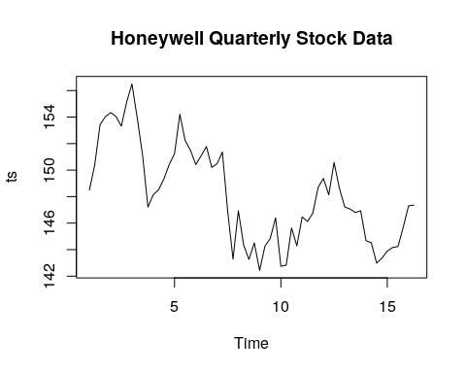

Afterward, I created accustom function, which takes the specific lambda value, and return the decomposition of this data according to this lambda value. Here, lambda value is equal to our ω in the objective function. Since it is suggested to use 1600 when data is quarterly, I adhered the guidelines and used 1600. After calculations, I plotted my time series data with the trend line which above decomposition gave me(Figure 1.2). Also, there is a cyclical component. From this figure it is obvious that Hodrick-Prescott filter did a good job in extracting the trend component of our stock data. This analysis and trend line are very beneficial in observing the long term trends. It enables us to focus on long term market instead of losing focus on the short-term fluctuations.

#### creating function for filtering with given lambda ####  
my_filter <- function(lambda){   
 data <- hpfilter(ts,freq = lambda, type = "lambda")  
 plot(data)  
 return(data)   
}  
my_filter(1600)

*Figure 1.2 – Hodrick-Prescott Filter of Stock Data*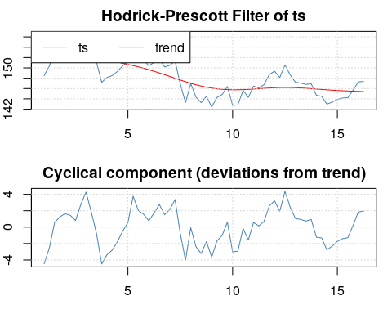

# Conclusion

To conclude, in this analysis, my main aim was to utilize Non-linear programming , more specifically quadratic programming. I was provided with quarterly Stock Prices (courtesy of finance.yahoo.com) of Honeywell Corporation. It was in time series format. I utilized Hodrick-Prescott optimization in order to decompose above time series data into its trend and cyclical components. Since it was quarterly dataset, I used ω = 1600 as a modifying parameter. As a result, we obtained both trend and cyclical components of the Honeywell Stock Prices data. One of the most important benefits of Hodrick-Prescott decomposition is its ability to present long term trend in the data. It filters out short term fluctuations and help businessman or analyst to focus on the long-term vision.

# References

Hodrick–Prescott filter. (2020, February 23). Retrieved from <https://en.wikipedia.org/wiki/Hodrick–Prescott_filter>

Honeywell International Inc. (HON) Stock Historical Prices & Data. (2020, March 28). Retrieved from <https://finance.yahoo.com/quote/HON/history?p=HON>